EXPERIMENT 11:

Write a R program to create a vector which contains 10 random integer values between -50 and 50.



EXPERIMENT 12:

Write a R program to get the first 10 Fibonacci numbers.

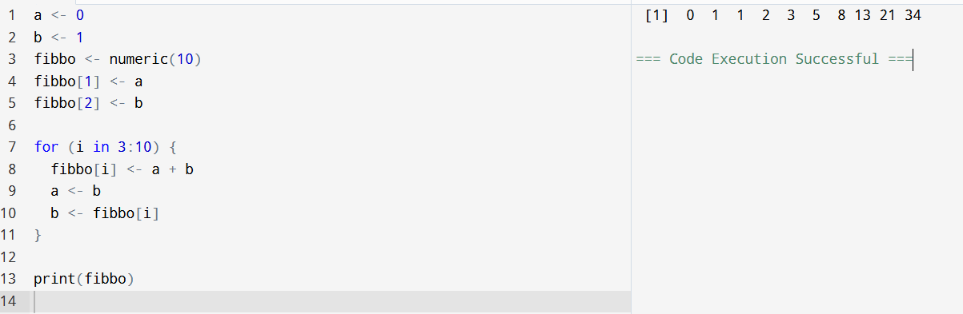

EXPERIMENT 13:

Prime numbers in given range.

EXPERIMENT 14:

FIZZ BUZZ numbers.

